Practical 5 – Data-Driven Web Based Application: Data Bindings and Rich Data Controls

Note: Connection string in your Web.config file should be as follows:-

<connectionStrings>
<add name="ConnectionString1" connectionString="Data Source=
(localdb)\v11.0;AttachDbFilename=|DataDirectory|\PlanetWrox.mdf;
Integrated Security=True"
providerName="System.Data.SqlClient" />
</connectionStrings>

Q1) Filter the reviews by genre. Display the genres in a DropDownList and use it to limit the reviews in the GridView to those that belong to the selected genre.

- Create a new Web Form called Reviews.aspx in the Management folder, and make sure it uses Code Behind.
- Switch the page into Design View. From the Standard category of the Toolbox, drag a DropDownList control into the page. On its Smart Tasks panel, select Enable AutoPostBack and click the Edit Items link. Insert an item with its Text set to Make a selection, and then clear its Value that was inserted for you automatically.
- Once you return from the ListItem Collection Editor dialog box, the Smart Tasks panel for the drop-down list is still open. Click the Choose Data Source item and choose <New data source> from the drop-down list at the top of the screen. The Data Source Configuration Wizard, shown in Figure 1, appears.

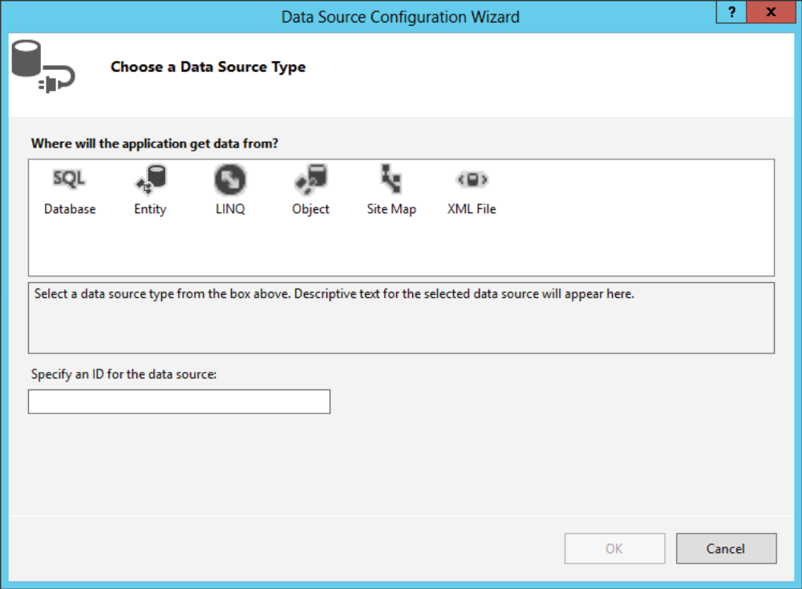
Figure 1

- Click Database, leave the ID set to SqlDataSource1, and click OK.
- In the dialog box that follows, select the connection string called ConnectionString1 from the drop-down list and click Next.
- Verify that the radio button for Specify Columns from a Table or View is selected. Also ensure that Genre is selected in the drop-down list with table names and then select the Id and Name columns in the Columns section. Click the ORDER BY button, choose SortOrder from the Sort By dropdown list, and click OK. When you’re done, your Configure Data Source wizard should look like Figure 2.

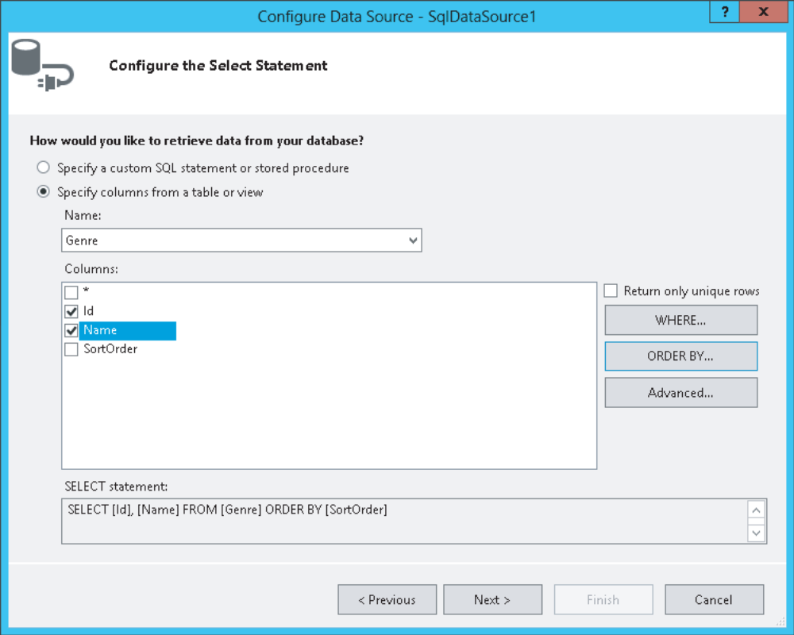
Figure 2

- Click Next and then Finish to have VS create the SqlDataSource for you. You return to the Data Source Configuration Wizard for the drop-down list where you can now set up a field that is displayed in the drop-down list for the genres and a field that serves as the underlying value in the list. Choose Name as the field to display and leave the second drop-down list set to Id. You should end up with the screen shown in Figure 3.

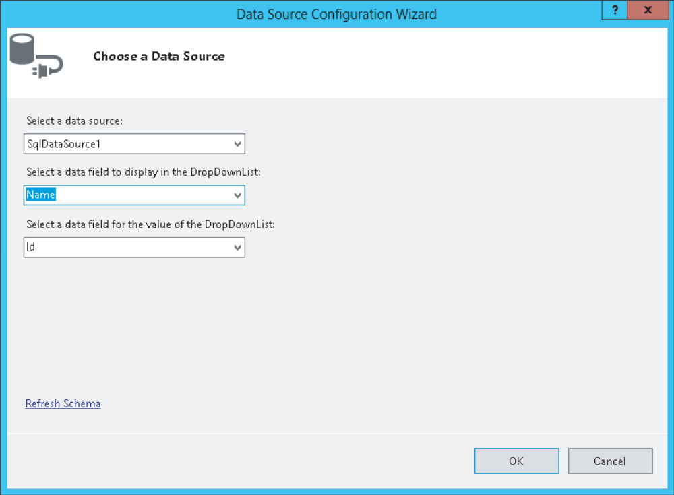
Figure 3
- Click OK to close the dialog box and finish setting up the data source for the drop-down list.
- With the DropDownList control still selected in Design View, press F4 to open up its Properties Grid and set the property AppendDataBoundItems to True. Switch to Markup View, and if the static ListItem that instructs your users to select an item does not have a Value attribute, add it manually and set it to an empty string. Your final code should look like this:

<asp:DropDownList ID="DropDownList1" runat="server" DataSourceID="SqlDataSource1"
DataTextField="Name" DataValueField="Id" AppendDataBoundItems="true"
AutoPostBack="True">
<asp:ListItem Value="">Make a selection</asp:ListItem>
</asp:DropDownList>
<asp:SqlDataSource ID="SqlDataSource1" runat="server"
ConnectionString="<%$ ConnectionStrings:PlanetWroxConnectionString1 %>"
SelectCommand="SELECT [Id], [Name] FROM [Genre] ORDER BY [SortOrder]">
</asp:SqlDataSource>

- Save all your changes and press Ctrl+F5 to open the page in the browser. You should now see a drop-down list with all the genres in the database ordered by their SortOrder column. Once you choose a new genre from the list, the page posts back to the server. Nothing else happens because you didn’t tie any logic to the DropDownList control, but you see how to do this in the next exercise.

Q2) Add another SqlDataSource that gets its data from the Review table. Creating a filter (the WHERE clause in the SQL statement) to limit the number of items displayed in the grid to those that belong to a specific genre.

- Switch the Reviews.aspx page to Design View and drag a GridView from the Data category of the Toolbox on top of the existing SqlDataSource control. The GridView is added right above it and its Smart Tasks panel opens.
- In the Choose Data Source drop-down list, choose <New data source>. In the Data Source Configuration Wizard, click Database (just as with the wizard for the genres that is shown in Figure 4) and click OK.

Figure 4

- In the dialog box that follows, select the ConnectionString1 from the drop-down list and click Next again.
- Select the Review table in the Name drop-down list and then make sure the asterisk (*) is checked in the Columns list to select all columns.
- Click the WHERE button, which enables you to set up a WHERE clause using the SelectParameters. In the dialog box that follows, enter the details so the screen ends up like Figure 5.

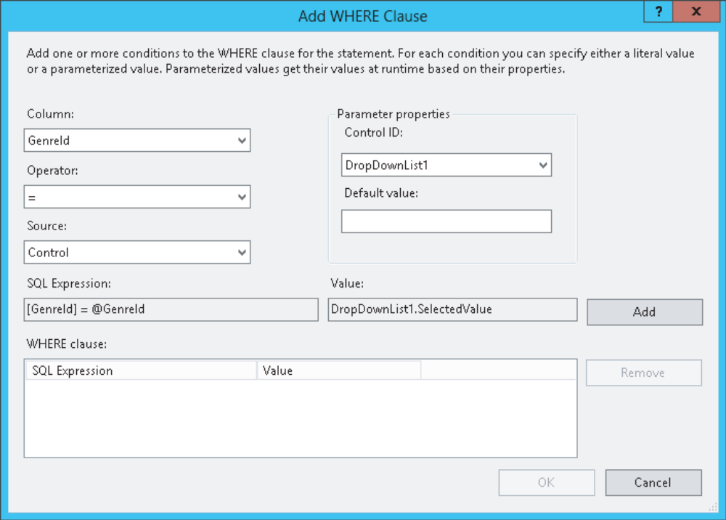
Figure 5

For some reason, each of your controls may show up twice in the Control ID drop-down list. It doesn’t matter which of the DropDownList1 options you choose.

- Click the Add button to add the selection to the WHERE clause list at the bottom of the screen and click OK.
- Back in the Configure Data Source wizard, click Next. To test the query, click the Test Query button. If you set up the parameter correctly, a dialog box pops up enabling you to enter a value. Enter a number that you know exists in the Genre table (such as 2) and click OK. If rows exist in the Review table for the chosen genre, they are displayed in the Test Query window. Finally, click Finish to finalize the wizard. If you get a dialog box about refreshing parameters, click Yes to have the code in Markup View updated for you.
- Save all your changes and open Reviews.aspx in your browser.
- Select a new item in the drop-down list. The page refreshes, and now shows the reviews that belong to the chosen genre. If the page doesn’t refresh, ensure that you set AutoPostBack to True in the previous exercise. At this stage the page looks rather messy because the GridView contains many columns.

Q3) Do the following in the Reviews.aspx page:
- Use the Fields editor to customize the fi elds for the GridView with reviews.
- Use a HyperLink column to create a link to a details page that enables you to manage the details of a review.
- Format the output of the existing BoundField columns.
- Use a custom function in the Code Behind to have full control over the output in a TemplateField.

- In Reviews.aspx, open the Smart Tasks panel for the SqlDataSource2 control in Design View and click Configure Data Source. Click Next to skip the connection string screen, and then complete the screen as shown in Figure 6 by selecting the Id, Title, Authorized, and CreateDateTime columns from the Review table. Make sure the SQL Statement box also contains the WHERE clause filter that you set up earlier. You may have to set this up again using the steps from the previous exercise because VS sometimes seems to lose this information.

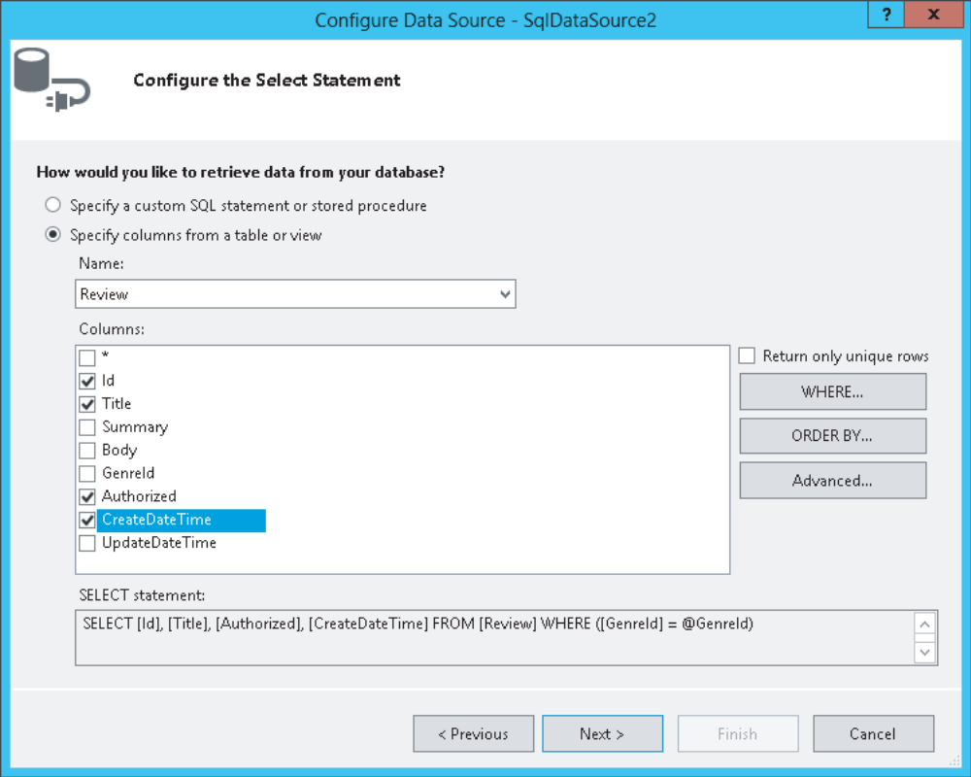
Figure 6

Click the Advanced button and have VS generate commands for the INSERT, UPDATE, and DELETE statements by checking off the fi rst item. You can leave the Optimistic Concurrency check box—which deals with detecting changes to the row since it was last loaded from the data source—cleared. Click OK to close the Advanced SQL Generation Options dialog box, then click Next and finally Finish to update the SQL statement in the source for the page. When asked whether you want to refresh the fields and keys for the GridView, click Yes.

- At this stage, VS has created columns for the GridView in Markup View. To remove those items and define your own, open the Smart Tasks panel for the GridView and click Edit Columns. This brings up the Fields dialog box. If the Selected Fields list contains items, use the Delete button (with the big X) to clear the list first.
- In the Available Fields list, select Authorized under BoundField (not the one under CheckBoxField) and then click the Add button to copy the item to the Selected Fields list. Repeat this step for the CreateDateTime field. Your dialog box now looks like Figure 7.

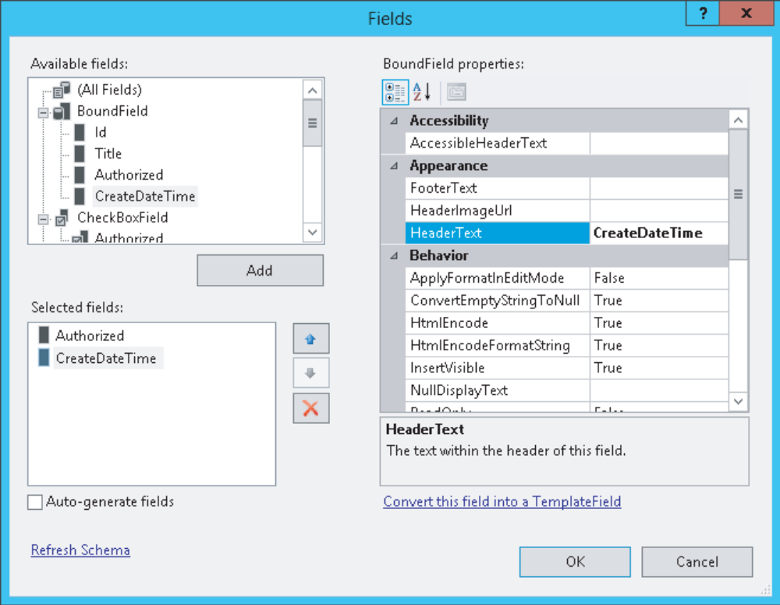
Figure 7
- In the Available Fields at the top of the screen, select HyperLinkField and then click the Add button to add the item to the Selected Fields list as well. Move the HyperLinkField to the top of the list by clicking the button with the up arrow twice. Then, using the Properties Grid on the right, set the following properties on the HyperLinkField:

PROPERTY SET ITS VALUE TO | PROPERTY SET ITS VALUE TO
HeaderText Title | HeaderText Title
DataNavigateUrlFields Id | DataNavigateUrlFields Id
DataNavigateUrlFormatString AddEditReview.aspx?Id={0} | DataNavigateUrlFormatString AddEditReview.aspx?Id={0}
DataTextField Title | DataTextField Title

- In the list with Available Fields, click CommandField and click the Add button again. Then set the HeaderText of the item you just inserted to Delete and ShowDeleteButton to True using the Properties Grid. This enables you to delete reviews from the database using the GridView later. The Fields dialog box should now look like Figure 8.

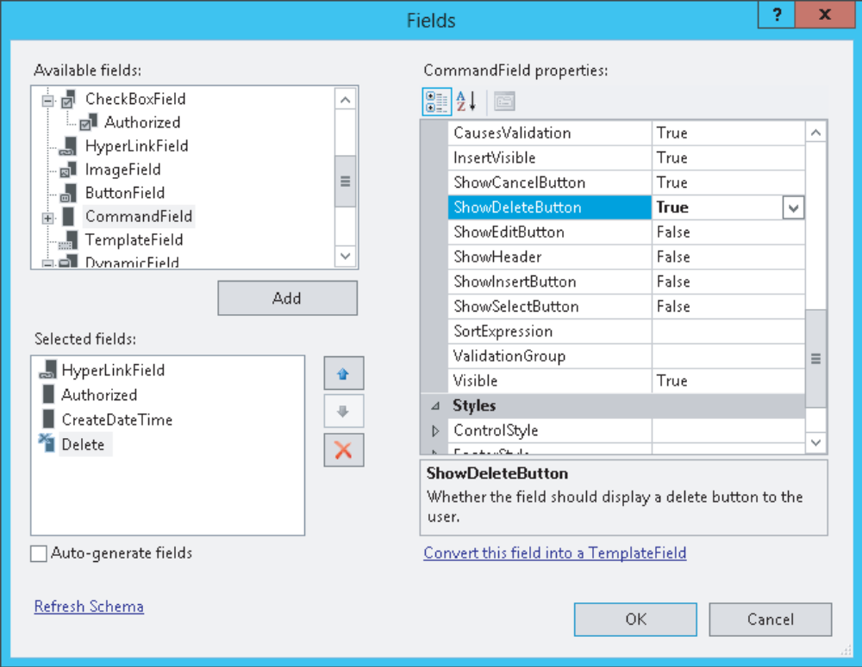
Figure 8

- Click the Authorized column in the Selected Fields list and then click the blue Convert This Field into a TemplateField link visible at the bottom-right of the dialog box in Figure 8.
- Click the CreateDateTime column on the left and set its DataFormatString property to {0:g}.
- Click OK to apply the changes to the source code.
- Switch to Markup View and remove the <EditItemTemplate> for the Authorized field. The GridView displays reviews only in read-only mode, so you don’t need this template.
- Modify the Label control in the ItemTemplate of the Authorized field so it ends up like this:

<asp:Label ID="AuthorizedLabel" runat="server"
Text='<%# GetBooleanText(Eval("Authorized")) %>' />

- Switch to the Code Behind of the page by pressing F7 and add the following function—which returns the text Yes or No depending on the boolean value that you pass—to the top of the class file, right after the Inherits line in VB.NET:

Inherits System.Web.UI.Page
Protected Function GetBooleanText(booleanValue As Object) As String
Dim authorized As Boolean = CType(booleanValue, Boolean)
If authorized Then
Return "Yes"
Else
Return "No"
End If
End Function

- Save all your changes (press Ctrl+Shift+S) and press Ctrl+F5 to open Reviews.aspx in the browser. Choose a genre from the drop-down list and you’ll see a list of reviews appear. Note that the Authorized column now shows the text Yes or No. The CreateDateTime column shows the date and time in a short format. Figure 9shows the result for the Indie Rock genre.

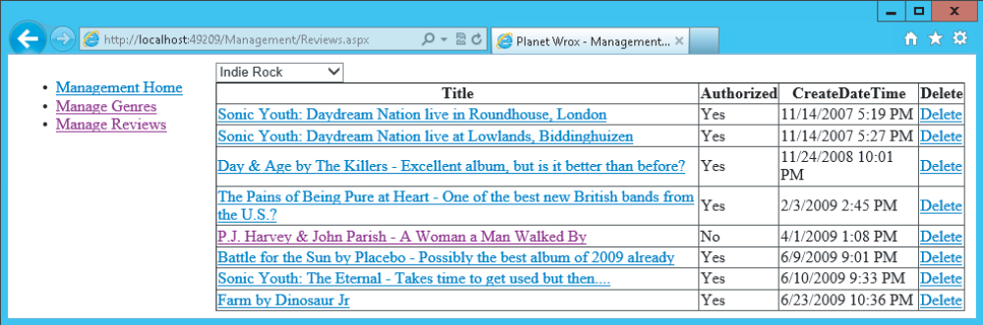
Figure 9

Note that the title in the first column of the GridView now links to a page where the ID of the review is passed in the query string field Id: http://localhost:1049/Management/AddEditReview.aspx?Id=1.

Part 2: Try on your own

Q4) Create the AddEditReview.aspx page. Add a DetailsView to this page, customize most of its fields by implementing template fields, and then handle some of the events of the control to change its behaviour.

